CSC8502

Arrow key up is default scene.

Arrow key left is scene 1.

Arrow key right is scene 2.

W is forward.

A is left.

S is back.

D is right.

Shift is to raise camera height.

Space is to lower camera height.

Demo here <https://youtu.be/UgVYirTlAqA>

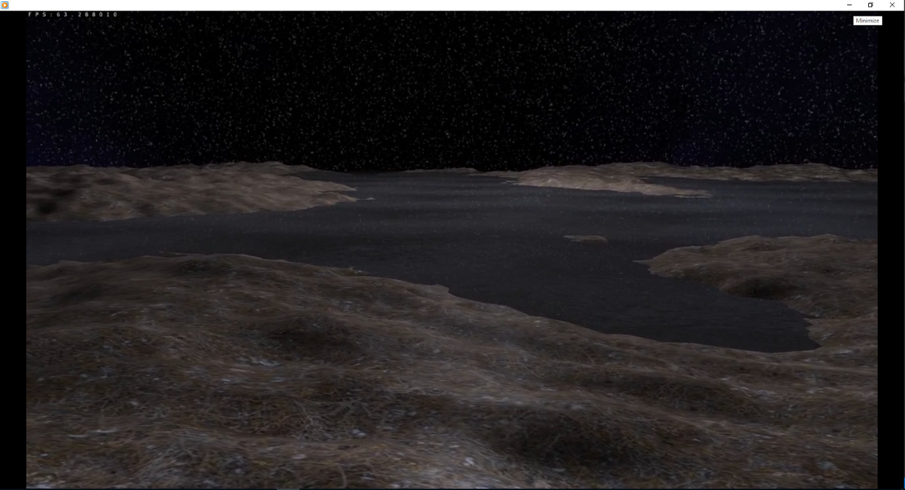Screenshots.

Working Reflections and cubemapping

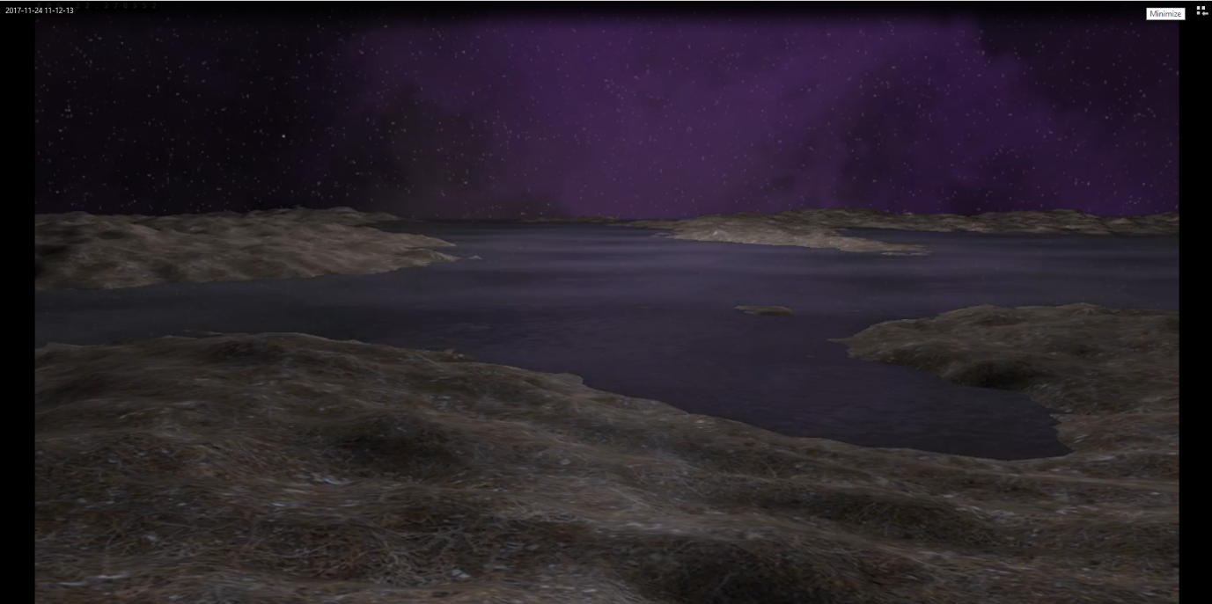

Working Reflections and cubemapping, with switching skyboxes

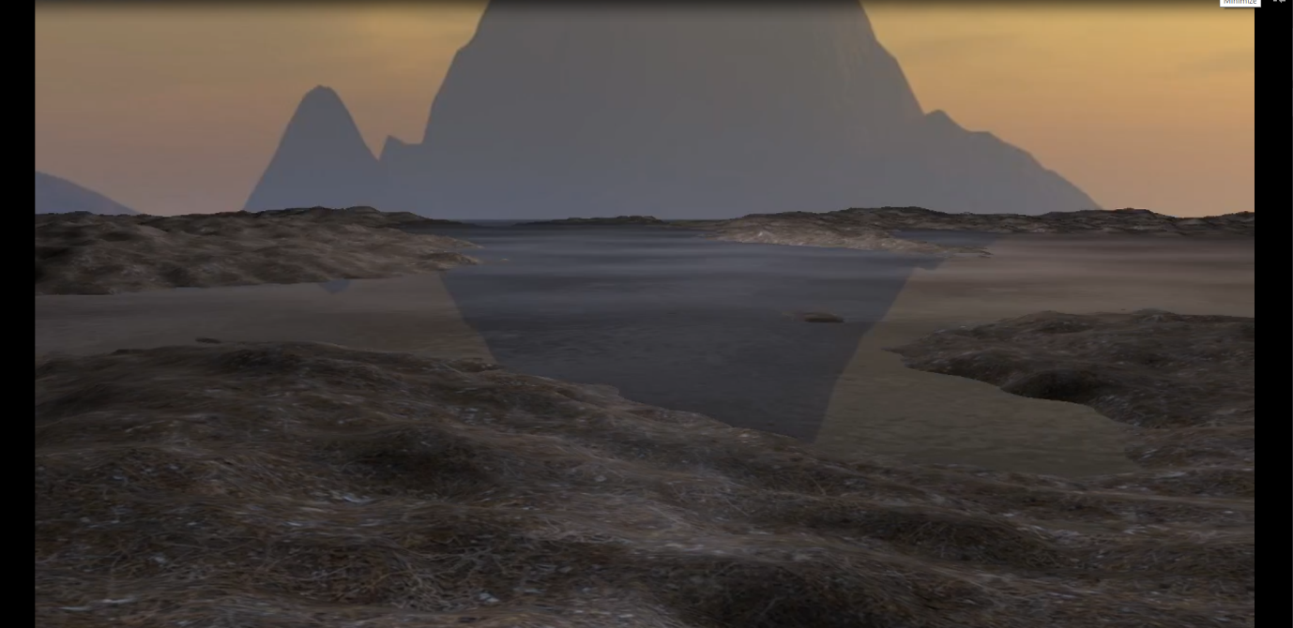

Working Reflections and cubemapping, with switching skyboxes

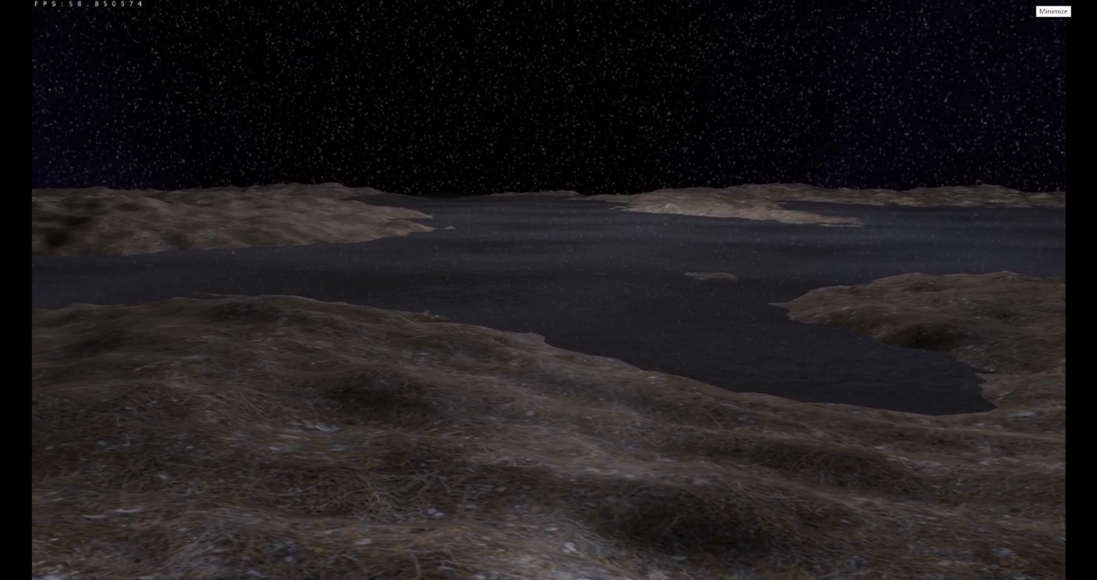

Specular, diffuse and ambient lighting, with subtle shadows.

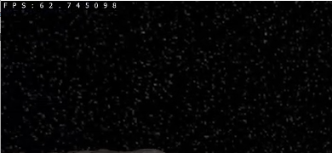

Working fps counter.